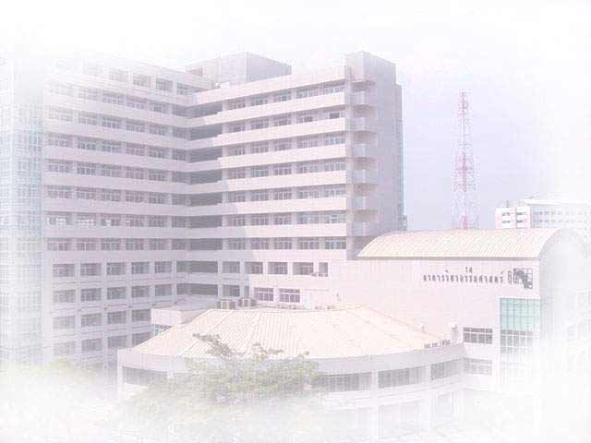
International Graduate Program in Civil Engineering
( IPCE )
Department of Civil Engineering, Faculty of Engineering, Kasetsart University
Major:

1. Structural Engineering (ST)
2. Construction Engineering and Management (CM)
3. Transportation Engineering (TE)

Second Semester 2010 Admission

- Academic Program 2 years 4 semesters (36 Credits)
- Academic Staff Kasetsart University
Tokyo Institute of Technology, Japan
Kumamoto University, Japan
Griffith University, Australia
- Class Schedule Monday – Friday 6.00 p.m. – 9.00 p.m.
Saturday 9.00 a.m. – 4.00 p.m.
- Qualifications Bachelor Degree in Civil Engineering
or related field and GPA > 2.5 or
GPA > 2.0 with 3 years working experience
- Expenditure About 65,000 baht per semester or 260,000 Baht
(6,500 U.S. dollars) per program
- Application Form Available at the web site and office all year round

- Application Now – October 31, 2010

- Start of Semester November 1, 2010

- Location Room 8505, Building 8, Faculty of Engineering,
Kasetsart University
- Inquiry Tel. 02-942-8555 ext. 1333
Tel./Fax. 02-579-3171
civilinter@ku.ac.th
- Website http://ceinter.eng.ku.ac.th

International Graduate Program in Civil Engineering
( IPCE )
Department of Civil Engineering, Faculty of Engineering, Kasetsart University

Second SEMESTER, 2010
ADMISSION CALENDAR

SCHEDULES | DATE
- Application Form Download  http://ceinter.eng.ku.ac.th | Now – October 31, 2010
- Submission of Application Form | Now –October 31, 2010
 | Mon – Fri  Sat | - 09.00 AM.–07.00 PM.  - 09.00 AM.–12.00 NOON
- Interview (English) | Oct 26, 2010 | - 9.00AM.–12.00 NOON
- Announcement of Successful Applicants | Nov, 2010
- Report and Receive Documents  for Registration | Nov, 2010
- Orientation for New Students | Nov 1, 2010
- Start of Semester | Nov 1, 2010
- English Examination | To be announced

➢ Contact No: Tel./Fax. 02-5793171

